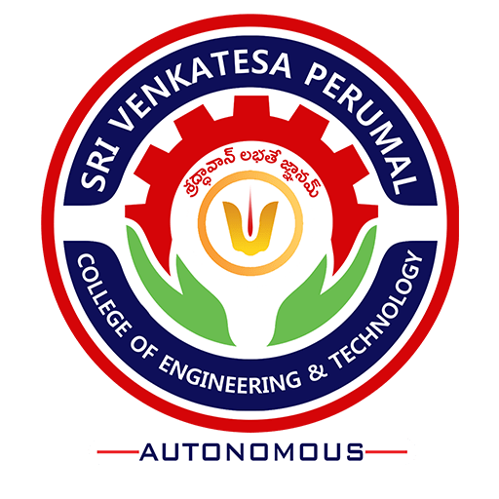

Code of Conduct of Students
(Revised)

November 2018

Sri Venkatesa Perumal College of Engineering and Technology
(Autonomous)
RVS Nagar, Puttur, Chittoor(Dist) - 517583
www.svpcet.org

CONTENTS

S. No | Topics | Page Number
1 | INTRODUCTION | 1
2 | DISCIPLINARY ACTION | 4
3 | FUNCTIONARIES UNDER THE CODE: | 6
4 | RIGHT TO APPEAL | 6
5 | UNDERTAKING BY THE STUDENTS | 7
6 | OPPORTUNITY FOR HEARING | 7
7 | ULTIMATE AUTHORITY | 7
8 | AMENDMENTS TO THE CODE | 7

Code of Conduct for Students

1. INTRODUCTION
The reputation of an institution depends primarily on the performance of its students. The students are not only known by their performance in their academics but also by their conduct which is an integral part of their personality.
The following code of conduct is expected from the students.
- Dress Code: Behavior, dress and projection in a dignified and respectable manner
- Belongingness: Develop a sense .of belongingness to the institution and Keep it up-right, clean and create a congenial environment
- Punctuality: Students must be regular and punctual to the classes and other co-curricular and extracurricular activities planned by the Departments/Institution.
- Discipline: Students must observe discipline. Indiscipline attracts punishment. They must observe self-imposed discipline in all activities, studies as well as others related to their stay in the College / Hostel.
- Informed: They should read the notices regularly, so as not to miss any important information.
- Respect: Their action must reflect respect for the Faculty members and must inculcate a spirit of fellow - feeling and mutual respect among themselves.
- Behavior in Academic sessions: They must behave well in the classrooms, laboratories, computer centers, seminar halls, library and other academic and recreation spaces.
- Reverence for women: Male students must not pass undesirable remarks at the female students and lady teachers and must maintain due courtesies.
- Campus maintenance: Students must not write anything or make undesirables sketches on the Walls/Furniture tops/doors or any other place on campus.
- Honesty and integrity in examinations: They should not attempt to copy in any evaluations or examinations.
- No to Drugs: Drug is a health hazard and students should not take drugs or consume intoxicants. Legal action shall be initiated on the students who are indulged in drug usage
- Information to parents: Students shall keep their parents Informed regularly about their performance in studies and other problems if any.
- Timely payment of Fee: They should make the payment of College/Hostel dues well in time.
- Anti-Ragging: Ragging is a crime. A student should not indulge in any form of ragging. Legal action shall be taken on the students who are indulged in ragging
- Respecting Diversity: No student shall be discriminated on the basis of the nation, state, religion, caste, creed, language, sex, etc.
- Ethical attitude: Students should comply with ethical code and professional conduct
- Attendance: A student will be admitted to a semester examination if he/she has attended regularly the prescribed course of study for the relevant semester and has attended not less than 75% of the total number of classes held. This requirement shall be fulfilled separately for each course of study as per the academic regulations.
- Detention: Provided that a student who has attended the requisite number of classes for the subject(s) will be eligible to appear in the examination in those subject(s). Provided further that a candidate who is deficient in attendance shall have to repeat those courses in which he is deficient, whenever offered by the College as per the academic regulations
- External Approvals: Any approval subject to University, Board and other external agencies shall be dependent on the agency concerned only. The institution shall not be responsible for these issues pertaining to external agencies.
- Legal Jurisdiction: All disputes pertaining to students are subject to the Jurisdiction of Courts at Puttur, Chittoor only.

2. DISCIPLINARY ACTION:
Any student exhibiting prohibited behavior mentioned in this Code shall be subjected to any of the following disciplinary sanctions:
Warning or Reprimand
The student engaged in any prohibited behavior will be issued a warning letter.

- Tendering Apology
The student engaged in any prohibited behavior may be asked to give an undertaking that he/she shall not indulge in such or any of the prohibited behavior in the future.
- Suspension
A student may be suspended from the Institute for violation of any of the provisions of this code. The period of suspension and conditions, if any, shall be clearly indicated in the communication addressed to the student by the college authority. The student shall lose his/her attendance for the suspended period unless decided/informed otherwise by the college authority.
- Restitution
Restitution implies reimbursement in terms of money and/or services to compensate for personal injury or loss, damage/disfiguration to the property of the institute or any property kept in the premises of the institute in any manner. The student/group of students may be asked to compensate for the loss that has been caused to any person or property of the institute or any property kept in the premises of the institution due to the act of vandalism perpetrated by the students. The student/group of students shall also be liable to put in their service to restore any loss or damage caused to any property and thereby bringing it to its original form if it is possible.
- Forfeiture
Caution deposit of any student engaged in any prohibited behavior shall be forfeited.

- Debarring from Examinations
A student/group of students may be debarred from writing all/any/some of the examinations, which forms part of the academic program for which he/she/they has/have joined if he commits some in-disciplinary act in examinations as per code of the evaluation under the Academic regulations
- Expulsion
This is the extreme form of disciplinary action and shall be resorted to only in cases where stringent action is warranted. Expulsion is the permanent dismissal of a student from the Institution. Such a student will not be eligible for readmission to any of the courses of the institution thereafter.

- FUNCTIONARIES UNDER THE CODE:
Faculty counselor: Each teacher as a mentor is allotted a set of students to monitor their progression and development during the student life on campus. The faculty counselor is responsible for the student compliance to the code of conduct and further escalates the issue to the Head of the Department concerned in case of any deviation.
Head of the Department: the Head of the Department shall be responsible to monitor the code of conduct of the students in the department and in case of any deviation, it is his/her responsibility to report to the Principal
Principal: The Head of the Institution is the final authority to maintain the discipline on campus and promote student compliance to code. He refers to all cases of deviation of the code to the disciplinary committee for an address of the issues before taking the final decision on quantum and type of punishment
- RIGHT TO APPEAL
The student (s) aggrieved by the action of any authority of the Institution under or subordinate to the Principal can appeal to the Principal. The decision of the principal shall be final and binding on the students.

- UNDERTAKING BY THE STUDENTS
The students joining any academic program of the Institution will have to give an undertaking to the effect that he/she will comply with the provisions envisaged in this code in letter and spirit and case it is violated, it will be bound by the provisions of this Code.
- OPPORTUNITY FOR HEARING
No order other than the order suspending or warning a student shall be passed without giving an opportunity of hearing to the student (s).
- ULTIMATE AUTHORITY
For all disciplinary matters related to students, the Principal shall be the ultimate authority as provided herein.
- AMENDMENTS TO THE CODE
The Chairman, Governing Body, Sri Venkatesa Perumal College of Engineering and Technology shall have the power to amend any of the provisions In this Code. The amendments shall be brought to the notice of the students and teachers of the Institution immediately.

